

Practices for Secure Software Report

Table of Contents
Document Revision History 3
Client 3
Instructions 3
Developer 4
1. Algorithm Cipher 4
2. Certificate Generation 4
3. Deploy Cipher 4
4. Secure Communications 4
5. Secondary Testing 4
6. Functional Testing 4
7. Summary 4
8. Industry Standard Best Practices 4

Document Revision History

Version | Date | Author | Comments
1.0 | [Date] | Jesse Martin

Client
Artemis Financial



Developer
Jesse Martin

Algorithm Cipher

Artemis Financial needs integrity verification on data transferred through its public web interface. I recommend SHA-256 (Secure Hash Algorithm 256-bit) from Oracle's Java Security Standard Algorithm Names for the checksum endpoint, combined with TLS 1.2+ HTTPS using a server certificate for transport protection (National Institute of Standards and Technology, 2015; Oracle, 2017).
SHA-256 is a one-way hash in the SHA-2 family defined in FIPS 180-4. It maps arbitrary-length input to a fixed 256-bit digest, typically shown as 64 hexadecimal characters. The JVM exposes it through java.security.MessageDigest with the standard name "SHA-256". SHA-256 is appropriate for checksum verification because collision resistance is strong for current threat models; legacy MD5 and SHA-1 are unsuitable for new integrity controls.
Symmetric algorithms such as AES encrypt bulk data with a shared secret key. Asymmetric cryptography (RSA in X.509 certificates) supports key exchange and server authentication in TLS. SecureRandom and proper key management matter for session keys and keystore passwords in production, even though this project uses a development self-signed certificate.
Encryption practice has moved from DES and weak hashes toward AES and SHA-2. Today financial and web workloads standardize on AES for confidentiality, SHA-256 (or stronger) for integrity, and CA-issued or carefully managed certificates for HTTPS. This project implements that stack at a lab scale: PKCS#12 keystore, HTTPS on port 8443, and SHA-256 checksum output at /hash.

Certificate Generation
I generated a self-signed RSA 2048-bit certificate with Java keytool and stored it in keystore.p12 under src/main/resources. The distinguished name includes CN=localhost for local HTTPS testing and O=Artemis Financial for scenario alignment. The alias tomcat matches Spring Boot server.ssl.key-alias in application.properties.
I exported the public certificate to artemis-localhost.cer for verification. Self-signed certificates are not trusted by browsers by default; production Artemis deployments would use a public CA (for example Let's Encrypt) or an enterprise PKI. For this assignment the export proves the key pair was created and is wired into the Spring Boot SSL connector.
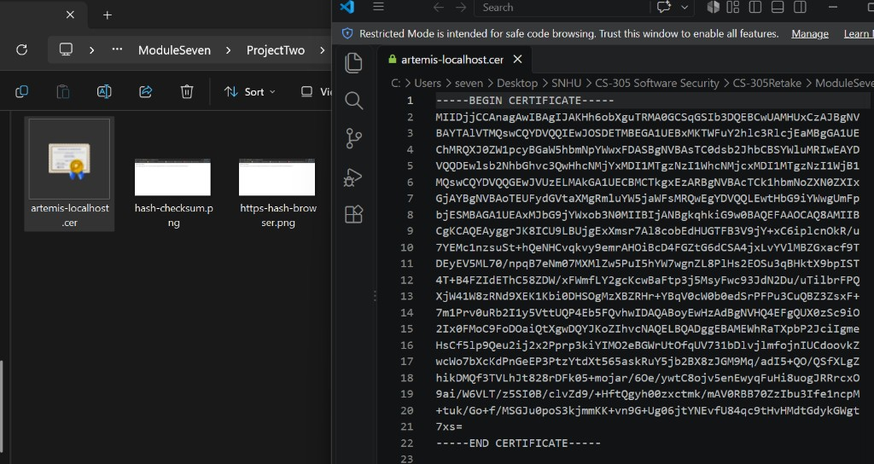

Deploy Cipher
HashController.java implements GET /hash. The unique data string is "Hello Jesse Martin!". The controller computes a SHA-256 digest over UTF-8 bytes and formats the result with a bytesToHex helper. A MAX_DATA_LENGTH guard (256 characters) limits oversized input if the endpoint is extended later. SslServerApplication.java remains the Spring Boot entry point only, separating bootstrap from web security logic.
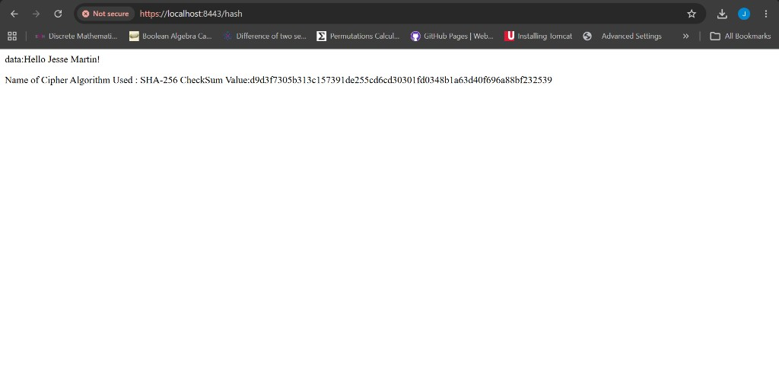

Secure Communications
application.properties configures server.port=8443 and PKCS12 keystore settings (classpath:keystore.p12, alias tomcat). HTTP listeners are not enabled; clients must use HTTPS. After starting SslServerApplication, https://localhost:8443/hash returns the checksum over TLS. Browser warnings for self-signed certificates are expected in development.

Secondary Testing
I upgraded dependency-check-maven to 11.1.1 and configured nvdApiKey from the NVD_API_KEY environment variable with ossindexAnalyzerEnabled=false, matching the secure pattern used in earlier course Maven work. I ran dependency-check:check after refactoring. The scan evaluates third-party libraries in pom.xml; my added Java files do not introduce new Maven dependencies, so the scan confirms the refactored build still reports known component CVEs from the Spring Boot stack rather than new artifacts from the checksum code.
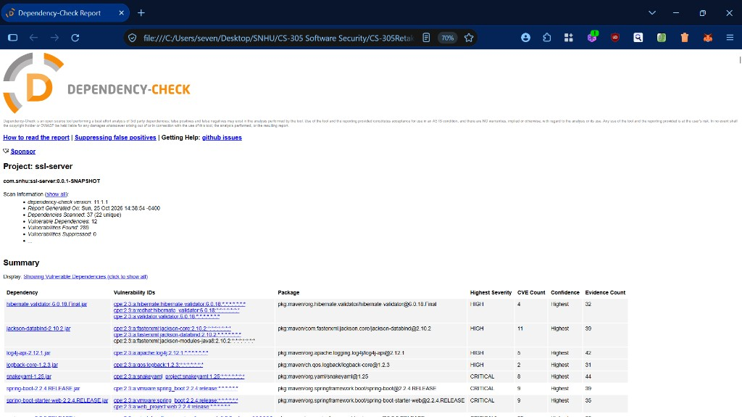

Functional Testing
Manual review covered HashController.java, SslServerApplication.java, application.properties, and pom.xml. Findings addressed: removed unused spring-boot-starter-data-rest dependency; added explicit input length bound in HashController; configured TLS properties instead of placeholder question marks; separated REST controller from main class for clarity. No hardcoded keystore passwords in Java source (properties file only, acceptable for this lab keystore). Compilation and Spring Boot run completed without errors.

Summary

Using the vulnerability assessment process flow, I addressed Cryptography (SHA-256 checksum, TLS keystore), Client/Server (HTTPS-only port 8443), Code Quality (controller separation, dependency cleanup), and areas tied to static testing (Dependency-Check in pom.xml). Layers added: (1) transport encryption via TLS, (2) integrity verification via cryptographic hash at /hash, (3) static composition analysis via OWASP Dependency-Check, and (4) manual review before submission.

Industry Standard Best Practices

I applied Oracle standard algorithm names, keytool keystore practices from Iron-Clad Java Chapter 6, and OWASP Dependency-Check guidance for SCA. Removing unused dependencies reduces attack surface. Bounded input and fail-fast checks follow secure coding guidance for REST endpoints. For Artemis Financial, these practices support client trust, reduce breach impact, and align modernization with audit expectations for financial data handling.

References

Let's Encrypt. (2026). Let's Encrypt. https://letsencrypt.org/

Manico, J., & Detlefsen, A. (2014). Iron-clad Java: Building secure web applications. McGraw-Hill Education. https://learning.oreilly.com/library/view/iron-clad-java/9780071835886/

National Institute of Standards and Technology. (2015). Secure hash standard (FIPS PUB 180-4). U.S. Department of Commerce. https://csrc.nist.gov/publications/fips/fips180-4/fips-180-4.pdf

Oracle. (2017). Java security standard algorithm names. Oracle Help Center. https://docs.oracle.com/javase/9/docs/specs/security/standard-names.html

Oracle. (n.d.). keytool - Key and certificate management tool. Oracle Help Center. https://docs.oracle.com/javase/6/docs/technotes/tools/windows/keytool.html

OWASP Foundation. (2025). Dependency-check Maven plugin usage. https://jeremylong.github.io/DependencyCheck/dependency-check-maven/index.html

